# **SecuriGo – How to Create a Batch Report**

**Date:** 2022-02-18

**Document Type:** Guide

**Prerequisites:**

1. Administrator access to SecuriGo
2. An internet connection either through Wi-Fi or Data Signal
3. Basic knowledge of GraphQL

**Introduction:** This guide will cover how to create a batch report from scratch using the batch report admin screen.

## **Section 1 – Navigating batch reports**

1. Navigate to the admin panel on the right and select Reporting -> Batch Reports to be directed to the batch report listing screen.
2. Once in the listing screen you will be able to search and filter between the batch reports if you need to find information on one.
3. An explanation of the columns are as follows:
   1. **ID –** Unique identification of the batch report
   2. **State –** Determines if the batch report is currently active
   3. **Name –** Name of the batch report
   4. **Description –** Contains a description of the batch report, what it does and when it runs etc.
   5. **Distribution Group –** The distribution group describes basically who the report will be going to and only exists in distribution batch reports. There are four major distribution groups that the batch reports serve:
      1. **Unblocked Users –** All users that are currently unblocked
      2. **Form Submitters –** All users that have ever made a submission
      3. **Contract Managers -** Users who are contract managers of sites with rounds grouped by site who aren't blocked
      4. **Regional Managers -** Users who are regional managers of sites with rounds grouped by region who aren't blocked
   6. **Recipients –** A list of emails separated by a semi-colon (;) that determines who the report gets sent to. An asterisk (**\*) i**n this case means all and is usually used in conjunction with contextual reports.
   7. **Schedule –** Describes when the batch report should run
   8. **Last Run –** Describes the last time the batch report was executed
   9. **Form –** What form the batch report uses to generate a report (if any)
   10. **Report –** The report template that’s attached to the batch report
   11. **File Type –** There are a few file types the report can generate such as:
       1. **0 –** PDF
       2. **1 –** Excel

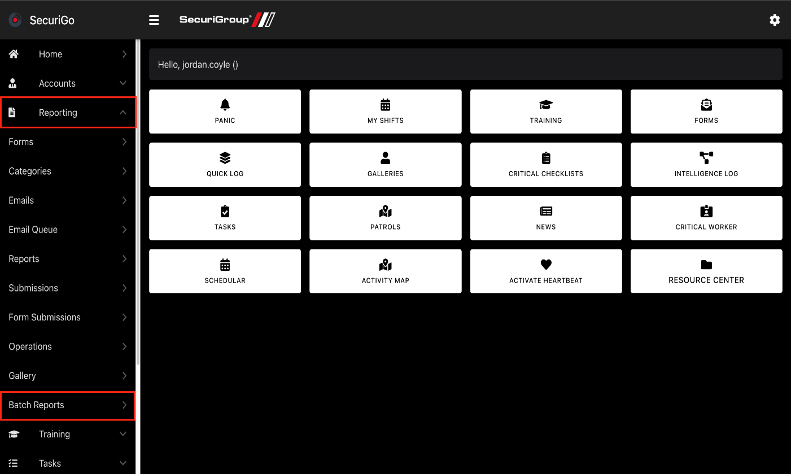*Navigating to the batch reports listing screen from the home screen*

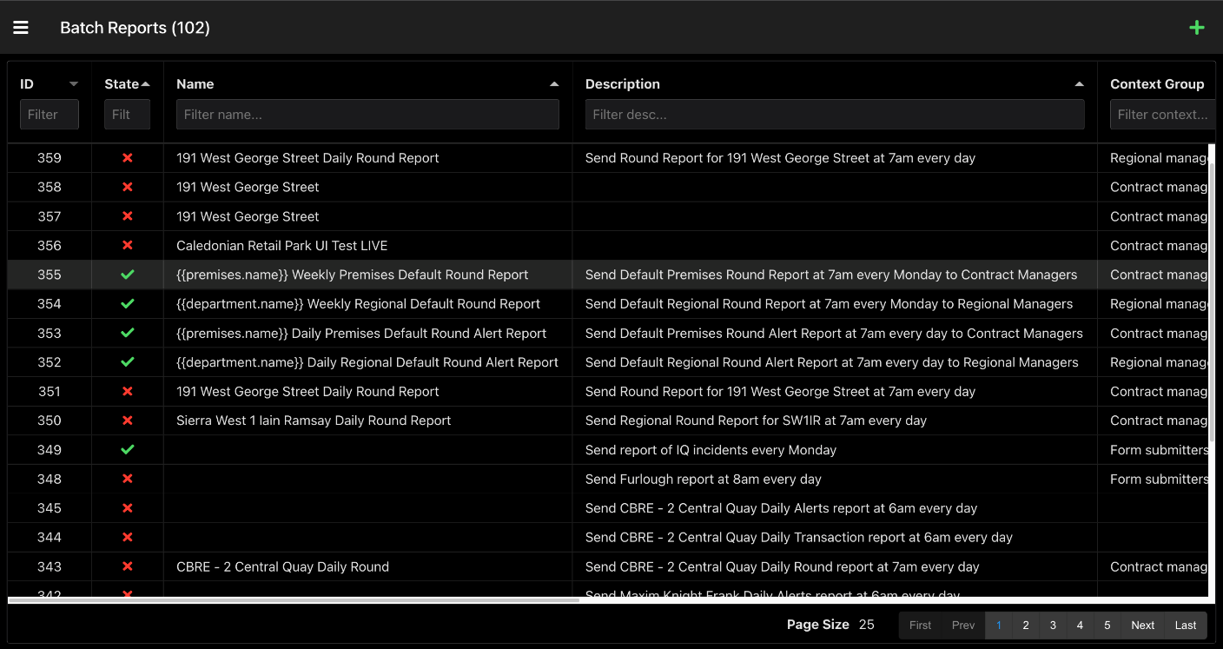*Example of how the batch report listing screen should look*

## **Section 2 – Editing batch reports**

This section will cover the editing of batch reports and what the various parts of the editing screen mean and how they function.

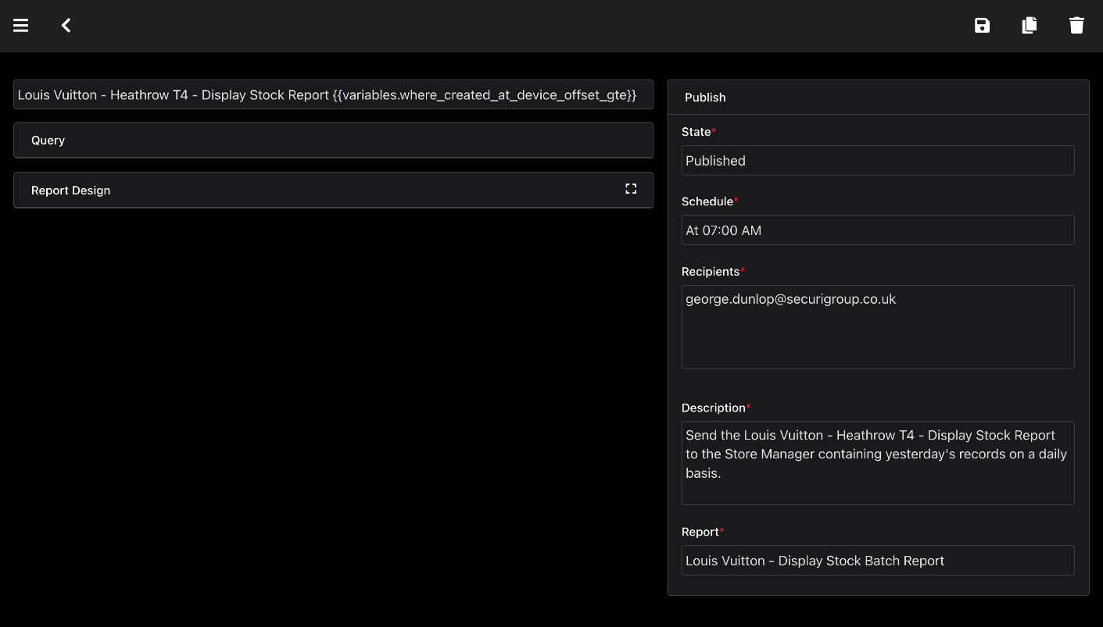*Example of publishing info and collapsed sections*

### **Publishing Information**

This part of the editing screen contains all of the editable publishing information relating to the batch report. There are multiple fields inside of the publishing section and each will be described in detail here:

1. **State –** This field describes whether or not the batch report is currently active and running
2. **Schedule –** This field describes when the batch report will run and deliver the reports. It contains a CRON designer that will allow you to build a custom CRON query. Please see the CRON designer section for details
3. **Recipients –** This field describes who exactly the reports will be sent to and has to contain a series of emails separated by a semi-colon (;) However if an asterisk (*) is used then the batch report turns swaps to a report that gets sent to specific distribution groups.
4. **Distribution Group -** This field only appears if the recipient's field has been set to an asterisk (*) and consists of the options: Unblocked Users, Form Submitters, Contract Managers and Regional Managers. See section 1 for details on these options
5. **Description –** This field contains a description usually detailing what exactly the batch report is and when it runs however you are able to write anything in here.
6. **Report –** This field contains the report template that the batch report will use to generate the report. You will be able to choose from all existing reports and if a report has to be edited you must do it in the report admin screen.

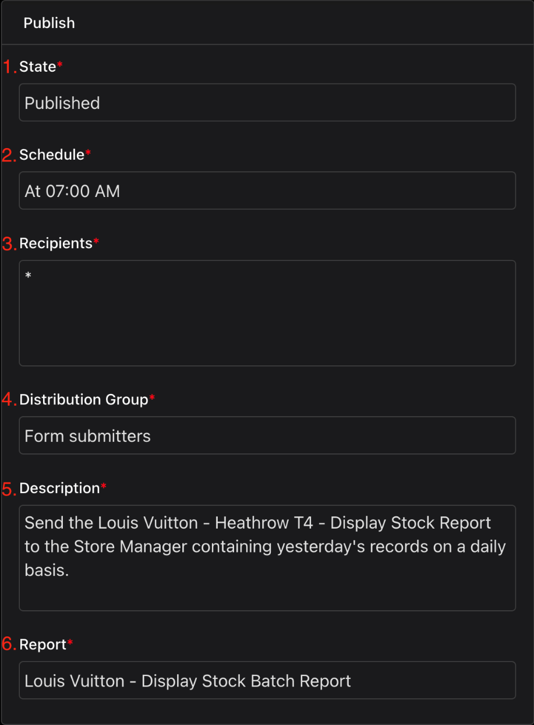

*Publishing data example*

### **Query Editor**

This part of the editing screen is a code editor that contains the query that the batch report will use to retrieve information from the database and generate the report. Some basic knowledge of GraphQL will be required to create or edit queries, some knowledge of the API structure will also be required here though you can refer to the in-built docs to help with this.

**Resource**: [Learn GraphQL](https://graphql.org/learn/)

1. **Query –** This section of the editor contains the main query that will be sent to the API and can query any information from the database.
2. **Variables –** This section of the editor contains the variables that the main query will use to get data. This can contain many variables that are defined in the documentation for the API, for example you can specify premises ID’s and creation dates.
3. **Results –** This section of the editor displays the results of the given query when you press the play button. This will give you an example of the data that will be injected into the report.
4. **Docs –** This section of the editor can be opened by clicking on the “Docs” button which will then display the documentation of the API which will tell you what can be queried and which variables you will be able to use.

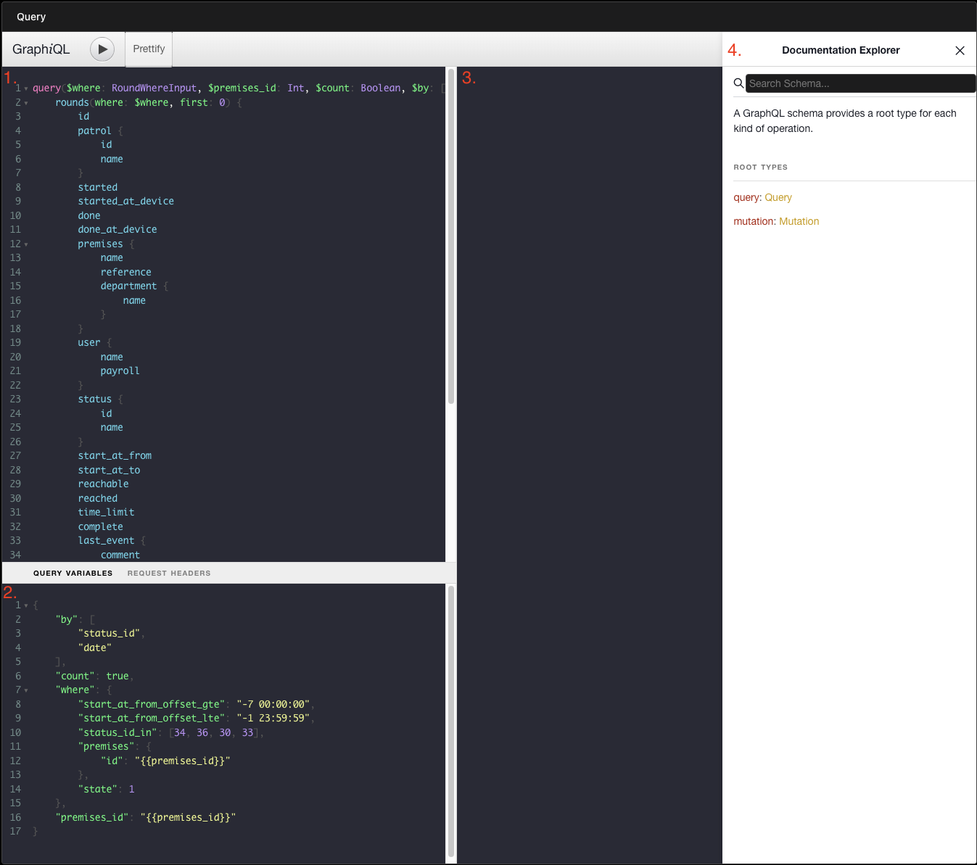*Example of the query editor*

### **CRON Designer**

The CRON designer is opened when specification is selected from the publishing information and is a powerful tool that allows you design a CRON task with minimal knowledge. A CRON task determines when the report will run and the designer screen contains a descriptor to make sure you understand when exactly the report will run.

1. **CRON Display - T**his part of the CRON designer displays the current CRON specification and any changes you have made
2. **Main Designer –** This is the main part of the designer and is where you are able to choose from various options in order to make the batch report run when you would like.
   1. **Minutes –** Contains various options to determine which minute the specification should include or every so many minutes
   2. **Hours –** This is very similar to minutes in terms of options
   3. **Days –** Here you can choose which day of the week you would like the specification to run or even a specific day in a month (1st-31st etc)
   4. **Month –** Again this is quite similar to previous tabs and you can choose specific months or every month.
3. **Specification Description –** This part contains a description of the current specification you have designed and should tell you exactly when it should run.

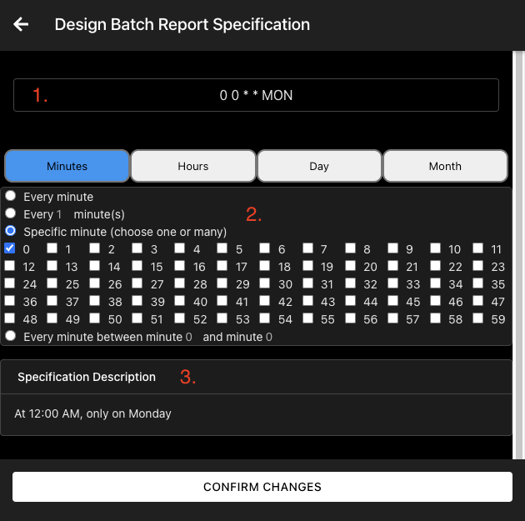

*Example of the CRON designer*

### **Report Display**

This part of the batch report admin screen is used to show the design of the report that will be sent out. There are two main parts of the display that are mainly used in this admin suite:

1. **Fullscreen Button** – button to display the report design using all of the screen.
2. **Preview Report Button –** This button is used to generate a preview of the report that will be sent out. It will use the current query in the query editor to retrieve the data used to generate the example report.

Any changes made to the report using the report display will NOT be saved. Changes to the report have to be made in the report admin screen.

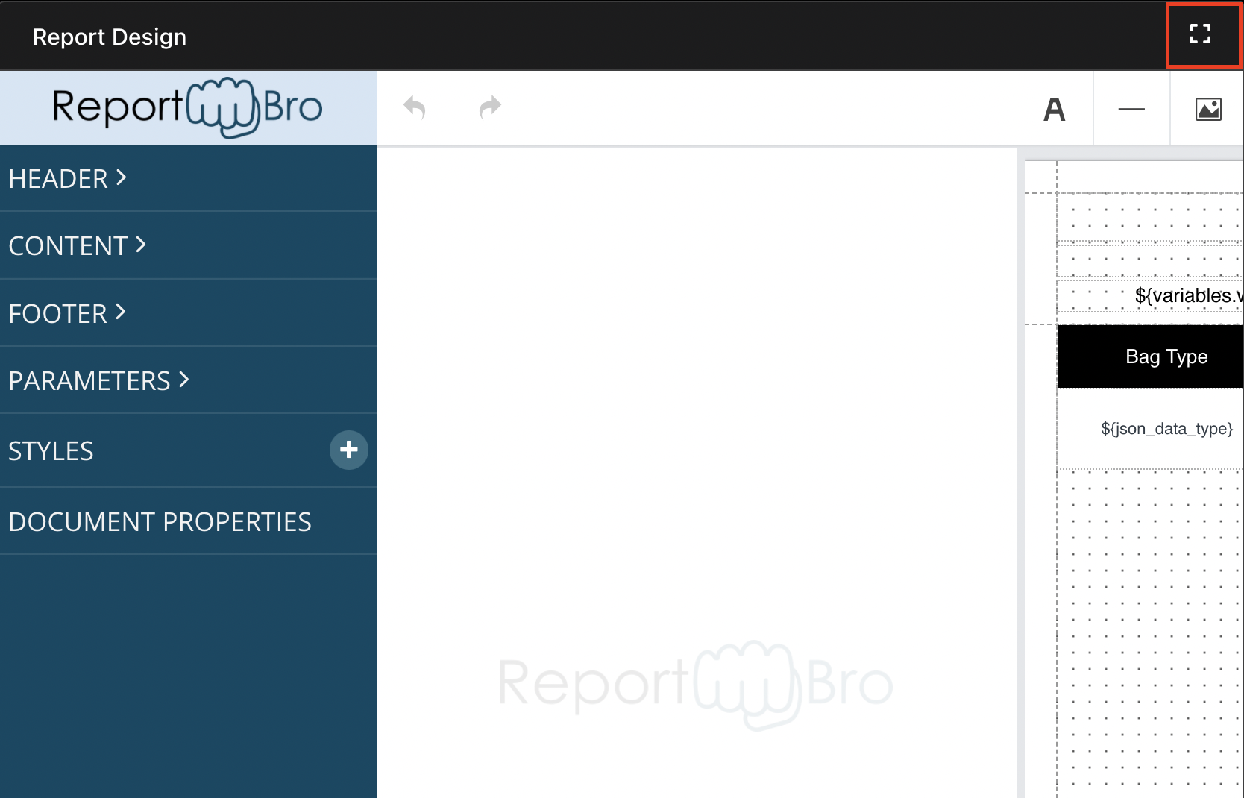*Example of the Fullscreen button*

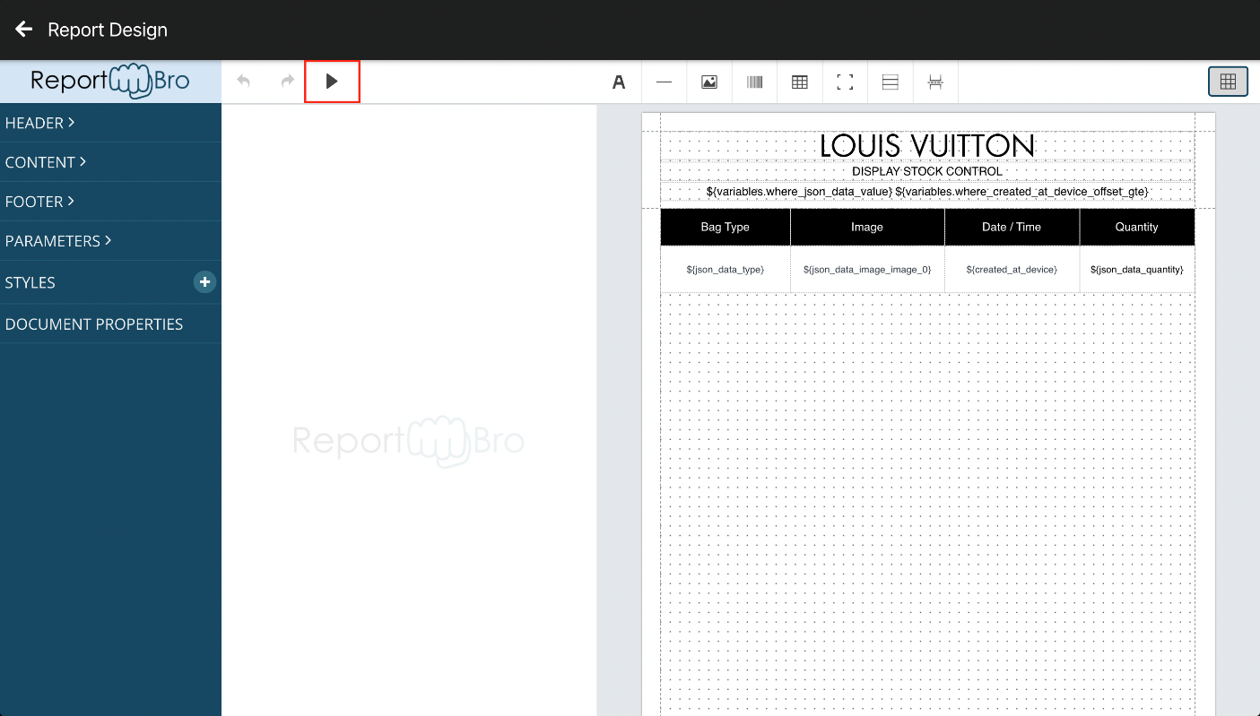*Example of the preview button in Fullscreen mode*